**Introduction:**

New York is the most populous city in the United States. It is diverse and is the financial capital of USA. It provides lot of business opportunities and business friendly environment. It has attracted many different players from all over the world into the market. It is a global hub of business and commerce. The city is a major centre for banking and finance, retailing, world trade, transportation, tourism, real estate, new media, traditional media, advertising, legal services, accountancy, insurance, theatre, fashion, and the arts in the United States. This also means that the market is highly competitive for all the people who want to do different kinds of business in the city. As it is highly developed city, so cost of doing business is also one of the highest. Thus, any new business venture or expansion needs to be analysed carefully. The insights derived from analysis will give good understanding of the business environment which help in strategically targeting the market. This will help in reduction of risk to entrepreneur and the other businessmen in the city. Moreover, the return on Investment will be reasonable to increase the profit of people.

**Dataset:**

I have used the dataset of New York to find the perfect location of Sushi Restaurant so that it becomes very popular and enjoy long-term success. I have downloaded the dataset from the following url: <https://cocl.us/new_york_dataset> and loaded it as newyork_data.json.

**Business Problem:**

The City of New York is famous for its excellent cuisine. The food culture includes an array of international cuisines influenced by the city's immigrant history of different kinds of restaurant in the city. Sushi restaurants have become so popular in the United States that now it seems that there is one on every corner, not only in major cities but also in smaller cities. Starting a sushi restaurant can be a great business opportunity, but you need to distinguish yourself from others to enjoy long-term success and for your restaurant to gain popularity in the city of New York.

**Find a suitable location:**

If you plan a real restaurant that can demand higher prices for fresh fish, delivered daily from Japan, focus on neighbourhoods and outlets that already attract a sophisticated Japanese client. If you plan a cheap buffet restaurant, points to the masses looking for affordable high-traffic locations with large shopping centres and other local points of interest. So, it is evident that to survive in such competitive market it is very important to strategically plan. Various factors need to be studied in order to decide on the Location.

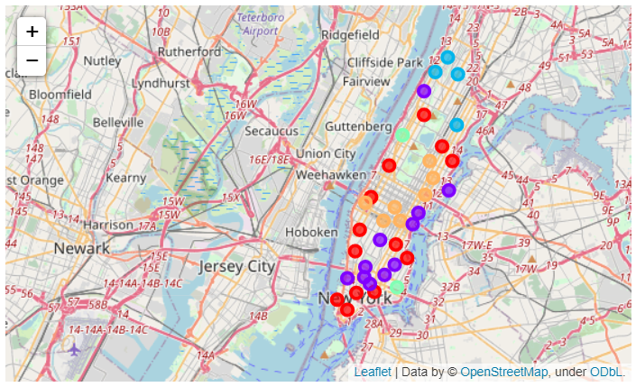

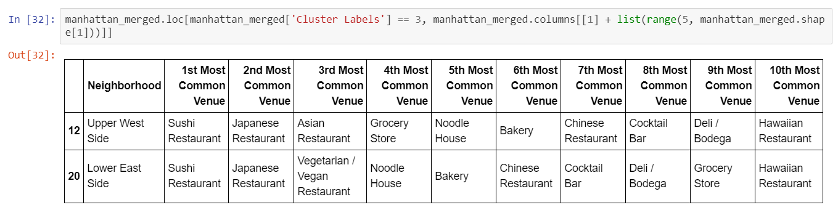

**Target Audience:**

If anyone wants to open business in Manhattan area, so I have only focused on that borough during my analysis. The objective is to locate and recommend to the management which neighbourhood of New York city will be best choice to start a restaurant. The Management also expects to understand the rationale of the recommendations made. This would interest anyone who wants to start a new restaurant in New York city and would help him to gain popularity and increase return on investment.

**Conclusion:**

Finally, I am able to find the perfect location for opening sushi restaurant in New York that will help the restaurant to gain popularity and help the restaurant enjoy long-term success by increasing its profit. As Sushi Restaurants are present at every corner in New York, I will advice anyone to open a Sushi Restaurant in **Upper West Side** or **Lower East Side** as they have the least such type of venues present and it will help the restaurant to gain popularity faster than any other locations.